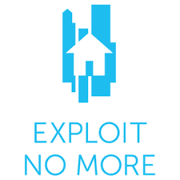

**REAL MILWAUKEE APPEARANCE PITCH**

To: Nicole Koglin

Co-Host and Anchor

Fox 6 Real Milwaukee

Subject: Appearance Request

Greetings Nicole Koglin,

Victims of human trafficking come in all ages, races and genders. Milwaukee County is one of the leading counties in Wisconsin when it comes to instances of this issue. With that in mind, Exploit No More, a local nonprofit dedicated to ending human trafficking in the Greater Milwaukee Area, is kicking off Human Trafficking Awareness Month in January with a donation drive at area churches, restaurants and businesses. These drives will be focused on collecting essential self-care and hygiene items for survivors as they transition themselves out of human trafficking.

As the leading network in Milwaukee for the midday audience and a mother of two young girls, we feel that coming onto “Real Milwaukee” and specifically talking with you, would be the best way for us to get our message out and increase the likelihood of a successful drive.

We are asking that you allow us time to come on your show to discuss our organization, the issue of human trafficking and our community partners that are aiding us in our mission.

I will be in touch in the next week to discuss any questions you may have and about scheduling an interview opportunity in early January to be on your show.

Thank you for your time.

Best regards,

Melania Klemowits